Sri Anar Devi Khandelwal Mahila Polytechnic, Mathura
Subject : Microprocessor and its applications
Class : Final Year Electronics
Prepared by : Alok Verma, Mob : 9411965990
The Block diagram of 8086 Microprocessor:

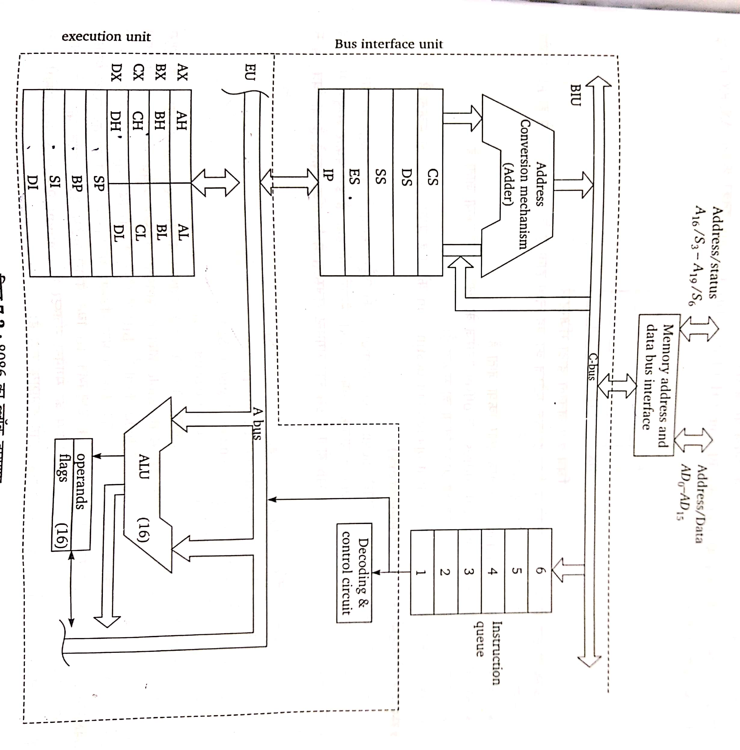
Fig shows the block diagram of 8086 microprocessor. The 8086 microprocessor is an improved version of 8085 microprocessor. It is a 16 bit microprocessor and supports 16 bit ALU. It has 16 bit register set in place of 8 bit register. It can address segmented memory. The instruction set and interrupt structure of 8086 microprocessor is more powerful. 8086 microprocessor has 16 bit data bus and can read or write 16 bit or 8 bit data. It has 20 bit address bus and can address 2²⁰ =1048576 ( 1 M Byte ) memory locations.
The 8086 CPU is divided into two parts, one is Bus Interface Unit (BIU) and the other is Execution Unit (EU). Since the CPU is divided into two parts, its processing speed is increased. The BIU fetches the instructions and data from memory and ports. The EU enables the availability of data and address on buses. The BIU maintains a 6 byte opcode queue. The execution queue receives the instruction object code and executes the instruction after decoding.
General Purpose Registers:
AX | AH | AL
BX | BH | BL
CX | CH | CL
DX | DH | DL

The 8086 microprocessor has 8 general purpose registers called as AH,AL,BH,BL,CH,CL,DH,DL. These registers can individually store 8 bit data. Some registers can be paired to store 16 bit data as AX, BX, CX and DX.
The register AL is also called accumulator and it has some extra features which are not available with other registers. AX can be used as 16 bit accumulator.
Segment Registers:The 8086 microprocessor can address segmented memory of 1 MB which is divided into 16 logic segments of 64 KB memory. In this way the total segmented memory size is 16X64 KB= 1024 KB or 1 MB. This segmented memory is divided into 4 segments as-
- Code segment Register, CS
- Data segment register, DS
- Stack segment register, SS
- Extra segment register, ES

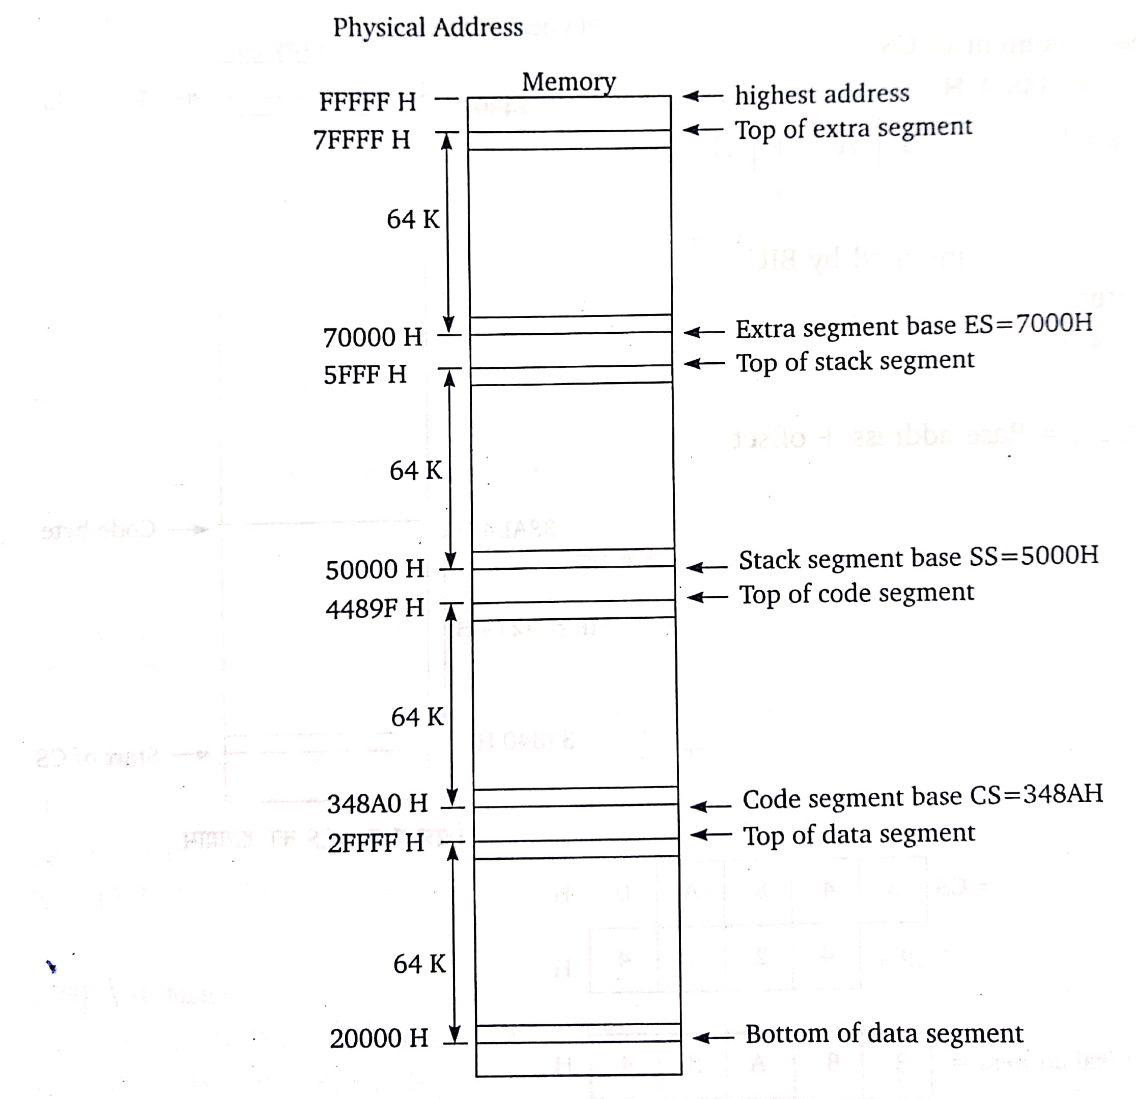

The segment register of the 8086 microprocessor work as base register ans indicate the initial memory address of the memory segment.
Instruction Pointer:
The instruction pointer of the 8086 microprocessor works as program counter and indicates the next instruction to be executed. The content of instruction pointer is auto incremented during the program execution. The content of the instruction pointer is also called the offset.
Pointer and index registers:
The following registers come in the group of pointer and index registers:
- Stack pointer SP
- Base pointer BP
- Source index SI
- Destination index DI

The function of SP is the same as that of stack pointer in 8085 microprocessor where as BP, SI and DI are used to find the physical memory address.
Flag registers:
8085 microprocessor has 16 bit flag register which has 9 active flags as shown in fig. Out of these 9 flags, 6 flags are conditional flags. These are –
CF, PF, AF, ZF, SF, OF
The remaining three flags are used to control some specific operations. These flags are different from conditional flags. The conditional flags are set or reset as per the results of arithmetic and logical operations but the control flags are set or reset as per specific instruction used in the program. The three control flags are-
TF, IF, DF
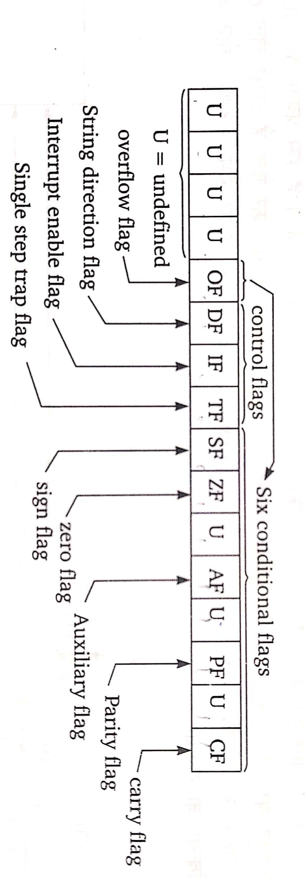QUEUE : When the EU is busy in decoding and executing an instruction, it does not need the buses. At the same time the BIU can fetch up to 6 instructions. The BIU keeps these instructions in first in first out ( FIFO) register which is called the queue. When the EU needs another instruction, it directly reads it from the Queue. This increases the speed of the processor because when the EU is busy in executing an instruction, during that time interval, the BIU stores the new instructions in the Queue.

