Sri Anar Devi Khandelwal Mahila Polytechnic, Mathura
Subject : Microprocessor and its applications
Class : Final Year Electronics
Prepared by : Alok Verma, Mob : 9411965990
The 8086 Microprocessor
The 8085 Microprocessor was an 8 bit Microprocessor. After that some 16 bit and 32 bit microprocessors were developed. Intel 8086/8088, 80186/80286, Zilog Z80, Motorola 6800 and NS 16000 of National Semiconductor are the examples of 16 bit microprocessors. The advantages of 16 bit microprocessors are-
- The capacity of microprocessors to address the memory is increased.
- The speed of execution of a task is increased.
- The instruction set of 16 bit microprocessors is more powerful.
- Programming is easy in high level language.
Pin description of 8086 Microprocessor
Intel 8086 is a 16 bit Microprocessor. It is a 16 bit microprocessor which uses 5 Volt power supply. The pin diagram of 8086 microprocessor is shown in figure.
- GND : Ground is applied at pin 1 and pin 20.
- AD₀-AD₁₅ : This is bidirectional address/data bus from pin 2 to pin 16 and pin 39.
- NMI : NMI signal is applied at pin 17. This is an input pin where non maskable interrupt is applied.
- INTR : Pin 18 is INTR pin where interrupt request is applied.
- CLK : Pin 19 is an input pin where clock pulse is applied.
- RESET : Pin 21 is the Reset input pin through which the system is reset.
- READY : Pin 22 is the ready input pin.
- TEST : Pin 23 is a test signal pin. When the signal at this pin is low the microprocessor continues the execution of instructions otherwise it comes into wait state.
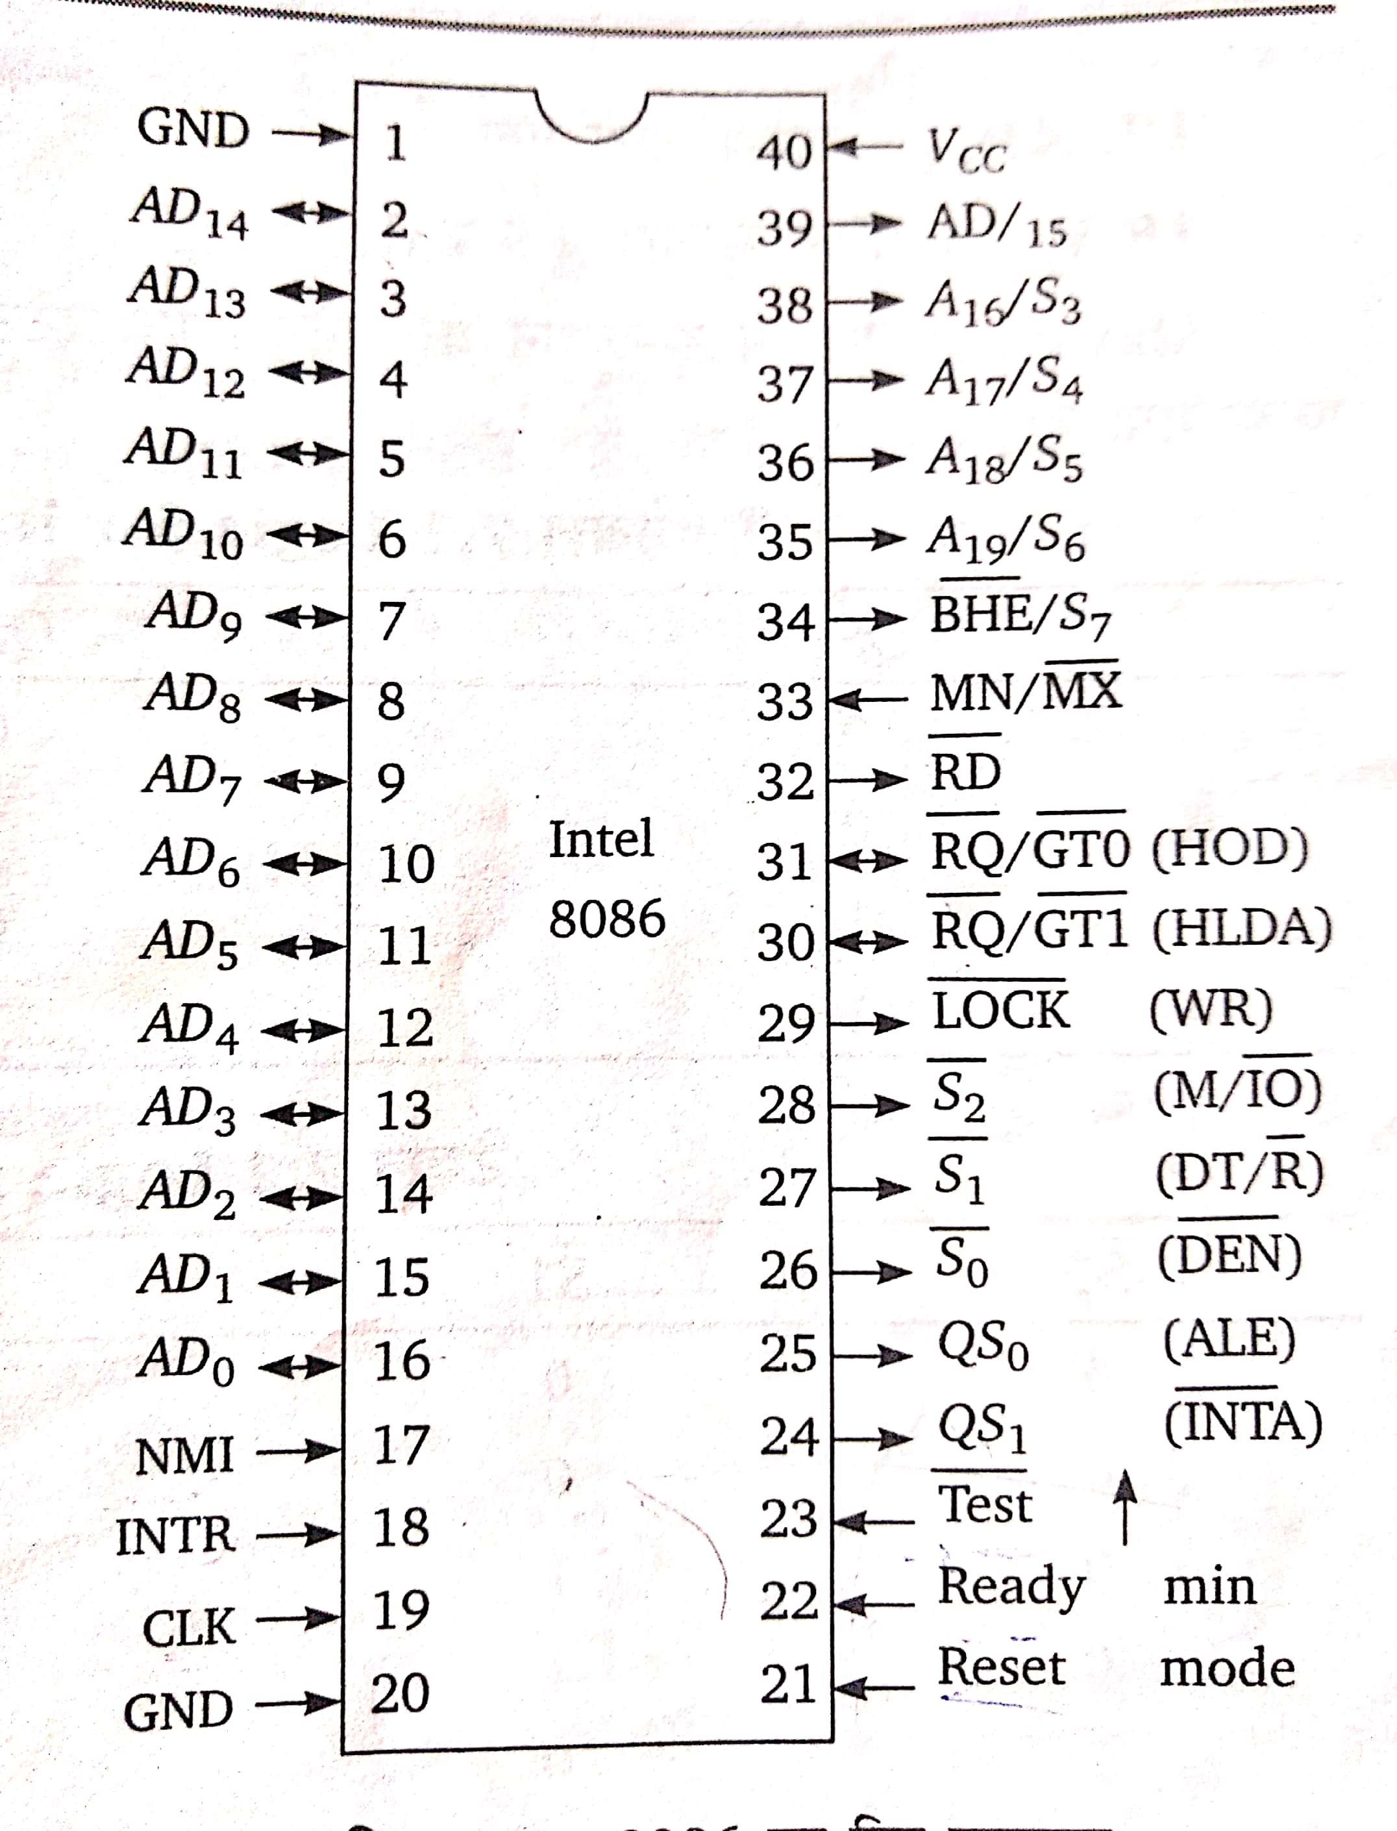
- QS₀/ALE and QS₁/I̅N̅T̅A̅ : Pin 24 and 25 show the status of the instruction queue. In MAX mode pin 24 works as I̅N̅T̅A̅ and pin 25 works as address latch enable.
- S₀₋ S₁ and D̅E̅N̅, DT/R̅, M/I̅O̅ : In MAX mode pin 26,27 and 28 work as status signal and in MIN mode these pins work as data enable D̅E̅N̅, data transmit-receive DT/R̅ and Memory or Input Output M/I̅O̅.
- L̅O̅C̅K̅/W̅R̅ : Pin 29 works as L̅O̅C̅K̅ in max mode and as Write W̅R̅ in min mode.
- R̅Q̅/G̅T̅1̅, R̅Q̅/G̅T̅0̅, and HLDA, HOLD : In max mode Pin 30 and 31 work as R̅Q̅/G̅T̅1̅ and R̅Q̅/G̅T̅0̅ and in min mode work as HLDA and HOLD pin. Both of these pins are bidirectional and are used for priority control.
- R̅D̅ : This pin number 32 is used for Read operation.
- MN/M̅X̅ : This pin 33 indicates the mode of the microprocessor. When the signal at this pin is low, the microprocessor operates in maximum mode and when the signal at this pin is high, the microprocessor operates in minimum mode.
- B̅H̅E̅/S7 : This pin number 34 shows bus high enable or status signal.
- A₁₆-A₁₉ / S₃-S₆ : Pin 35 to 38 are high order address bus which is multiplexed with status signal.
- AD₁₅ : Pin number 39 is Address data pin.
- V_{cc} : Pin number 40 is power supply +5 V dc pin.
Maximum and Minimum Modes : The function of Pin 24 to 31 depend on the operating mode of the microprocessor and the operating mode of the Microprocessor depends on the signal at input pin 33 ( MN/M̅X̅). When the signal at this pin is low, the microprocessor operates in maximum mode and when the signal at this pin is high, the microprocessor operates in minimum mode.

